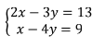
Example 1: Solve the system of linear equations by substitution

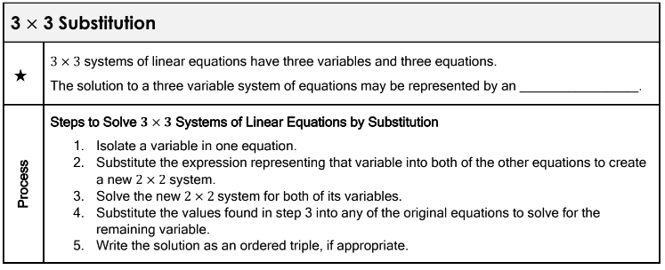
Example 2: Solve the system of linear equations by substitution
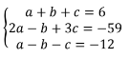

Example 3: Solve the system of linear equations by substitution
